Abstract

This document contain the initial documentation of the AFDCCK project in addition to answering the questions asked by the assignment

Name: Sebastian John Perry || Student Number: S5132483

sebastian.perry@griffithuni.edu.au

A(utomated)

F(ilm)

D(istribution),

C(reation), and

C(ollection)

K(iosk)

initial Project Documentation

A 2813ICT Software Engineering Fundamentals Assignment

# Project Name (1):

Automated Film Distribution, Creation, and Collection Kiosk

Or

AFDCCK

# System Vision (2): (331 words)

## Problem Description:

It has been discovered that profits can be increased in the renting and sales of DVDs. A system must be developed that can eliminate the need for the employment of sales clerks, and eliminate the need to manage the distribution of certain film media to site locations.

It has be decided that an automated standalone kiosk machine should be developed such that it is able to handle the storage and creation of film media so that it can be sold to customers in a fast, efficient and autonomous fashion.

## System Capability:

The desired system should be capable of:

* Digitally receiving new movies and committing then to the machines storage
* Creating film media e.g. burn the movie onto a cd, print the box art, and assemble the product
* Storing the created physical media copies of the films
* Storing relative information on the film (such as genre, rating, trailers, tags, and description)
* Creating and storing information for customer accounts
* Allowing users to buy, rent (and by extension return) film media from the kiosk
* Advertise recently released / popular films on the kiosks screens to passer-by’s while the machine is sitting idle

## Business benefits:

Some business benefits would include:

* Profit lose through wages to sales staff will be mostly removed; this is only mostly as it is important to remember that some of the funds will need to be redirected towards the running and maintenance costs of the new system.
* Less staff will need to be hired for the upkeep of this system than that which was required for the store.
* As the machine can create the movies on site no additional systems or team will need to be in charge of logistics of certain movies to certain machines. The machines will just be supplied with components and it will handle stock levels when appropriate.
* A machine will be more consistent at upholding at upholding the company’s core beliefs and policies.
* The machine will be open for business twenty four hours a day, every day of the year; this will in turn increase operating hours, and as a result increase revenue.
* While it may seem incredibly obvious it is worth mentioning that a machine will not cost more to operate on holidays were as sakes staff would

# Cost Benefit Analysis (3):

## Project Cost Benefit Graph:

## Basis of Prediction:

Above is seen a graph of the impact that the project is expected to make on company profit. While the creation of the graph and a breakdown of its values will be discussed below, the research and subsequent tables created to make this projection can be found in appendixes 1-4.

## Graph Elaboration:

The graph show above shows the impact the project would make on the profit margins of the company if it were to be undertaken over the year of 2020 and put into effect in 2021. The graph takes into consideration the expected net Revenue through the use of an equation (with an R squared value of around 0.98) that has been created using researched market trends. This graph shows the impact that would be experienced by undertaking the project in addition to showing the operational costs of the sites before and after the project would come; as a result graph does show that while the company is expected to make a net loss in the year of 2020, it is also expected to make reach profit margins which previously haven’t been achieved since 2017. The extremely low operational costs of the sites after the project will ensure that the company continues to make a profit in the near future.

## Cost Benefit Summary:

Under the current operational costs of the sites totalling at $1.3 million per year (factoring in shop rental ($343,200) and staff rates ($995,100)), completing this project would bring down operational costs of the sites to $1000 per year (factoring in machine space ($900) rental and upkeep ($100)) after completion of the project (this is given under the assumption that the number of sites would stay at 20). This project would be completed over the duration of a year during which the employee of two senior developers (equating to $130,723) and 8 junior developers (equating to $53,143) would be required. After the project is completed it is predicted that the production cost of the Kiosks per unit would be around $20,000 (equating to $400,000 in total for all 20 sites).

# Risk and Feasibility Analysis (4):

## Risk Table:

Below is a table that contains amount of various different risks that have been considered. Listed is their category, the risk itself, its probability of happening, it cost if it were to happen, and the different proposed solution planned to mitigate the risk.

|  |  |  |  |  |  |
| --- | --- | --- | --- | --- | --- |
| Category | Risk | Probability of Risk occurring | Cost Risk will Incur | Actions Planned to Reduce Risk | |
|  |  |  |  | 1 | 2 |
| Market |  |  |  |  |  |
|  | With the rise of Netflix and other such online streaming services physical film media might lose relevance and market value, in turn causing a net loss of assets focused on this project | high | high | Sites will include areas of lower residential income (where the chance of online service ownership would be lower due to the price), by supplying a cheaper rental option sales will be kept up. | There is still a market for supplying physical film media for those who collect it. As such it will be possible to order the machine to construct premium quality DVDs (such as Blu-ray) that can come in a limited edition case that can also be personalised. This would make our products desirable to such individuals. |
| Management |  |  |  |  |  |
|  | A high amount of rentals on a single film could cause a machine to create too much media and as a result become over stocked upon return of the media. | high | low | Machines will have a storage bin where it can keep over stock. Once this bin has been filled (or enough time has passed) the machine will notify maintenance staff to collect the extra media before either, redistributing it to other machines, or returning it to HQ so that it can be sold to 3rd party companies at a decreased profit margin. |  |
| Resources |  |  |  |  |  |
|  | It is possible that the working of the machine could be more complex than first expected, causing the project to take up more time than first thought | high | high | The amount of time that has been allotted to complete this project spans the duration of a year, and the team creating the software contains 10 people. This means there's a lot of time and people to tackle any problem which may arise. | The team taking on the project will consist of 2 senior developers and 8 juniors. To avoid unexpected project surprises the juniors will focus on the majority of the programming work, whereas the seniors will be more focused on designing elements ahead of time and coordinating the junior developers. |
| Technological Aspects |  |  |  |  |  |
|  | some site locations may not have readily available Wi-Fi to allow easy communication between the machine and HQ | medium | medium | All kiosks will be fitted with their own mobile cellular data sims that will allow them to communicate without external surrounding wireless connection. | The machine will have its own data storage solution on-board which among other things will allow it to store relevant information and records of transactions, this will allow the machine to continue doing some of its functionality even if it loses connection to the central database, it will just be required to update and receive updates from the central database when connection is re-established. |

# Stake Holder Concern Definition (5):

## Different Stakeholders and Their Concerns:

Below is a short summary of the various different stakeholders and their concerns relating to the proposed project:

### Marketing teams:

The marketing team will be concerned with the project being able to offer new, never before seen features that cannot be offered by competitors (such as online video streaming services or other DVD rental establishments); such features would give the company a leg up on the competition, making the products more desirable in the eyes of the consumer and as such raising sales and by extension the company’s profit margins.

### Maintenance teams:

Maintenance teams will be concerned with the system being easily maintained. They’ll want the kiosk to be easy to keep clean and stocked with all the things it needs to in order to keep generating revenue. Furthermore they’ll also want the system to be robust and durable while still being modular should certain elements need to be repaired, modified, or replaced.

### Management:

Management will be concerned with having a system that can be easily controlled and modified while still being able to sell products effectively without human intervention. Furthermore management will want the system to manage stock levels, stock fabrication, and overstock management so that profit margins can be increased through the removal of the site’s requirement for human employees.

### Investors:

Investors will be concerned with getting a finished product that is capable of generating revenue at a scale comparable to that seen with the previous site configuration while also lowering costs, so that the profit margins can stay viable despite the recent decline in market revenue.

### End Users:

End users will be concerned having a system that can provide the service they received from the previous site (getting DVDs). The customer will want this process to be just as (if not more) easy and convenient as it was to get DVDs from the old store setup. They’ll want new and interesting features that they haven’t seen before, with products that are of comparable quality and competitive price to that of the competitors.

# Functional / Non Functional Requirements with FURPS (6):

## FURPS Requirement Table Breakdown:

|  |  |
| --- | --- |
| FURPS Requirement | Requirements |
| **Functionality** | * The kiosk should be able to sell DVD’s * The kiosk should be able to both dispense DVD’s and accept them * The kiosk should be able to manage the complete renting out and returning process * The kiosk should be able to be able to fabricate new DVDs using supplied films * The kiosk should be able to store multiple DVDs and have the capabilities to select certain ones when required |
| **Usability** | * The user side of the software should consist of well-spaced out graphic interfaces with large lettering and relevant iconography * The kiosk should have an interface which has the option to be displayed in a variety of different languages, this option should be easy for the user to change at any time however after use it should default to an option which is suitable for its geo-graphical location |
| **Reliability** | * The kiosks should contain on-board memory which will allow them to continue completing simple functions even in the absence of a wireless connection to HQ. * The kiosk should be tested to insure that the condition scan of the DVDs (the hash that will determine if users are required to pay for damages at the end of rental period) is functioning correctly and doesn’t give false results. |
| **Performance** | * The kiosk should try to predict rental trends and print DVDs it may need ahead of time in order to reduce customer wait times * The DVD fabrication solution ultimately chosen should have a focus on power efficiency over time efficiency as it is unlikely that a User will sit and wait for their ordered DVD to complete, rather it’s much more likely the user will come back later |
| **Supportability** | * As this is a standalone kiosk it can be installed anywhere that has access to power sockets. * The Kiosk should be able to fabricate, store and sell the DVDs 100% automatically, only requiring occasional deliveries of raw materials * The kiosk should be modular in design so that parts can easily be switched out in the event that modification or repair is required |

# Major System Requirements (7):

## Use Case Diagram:

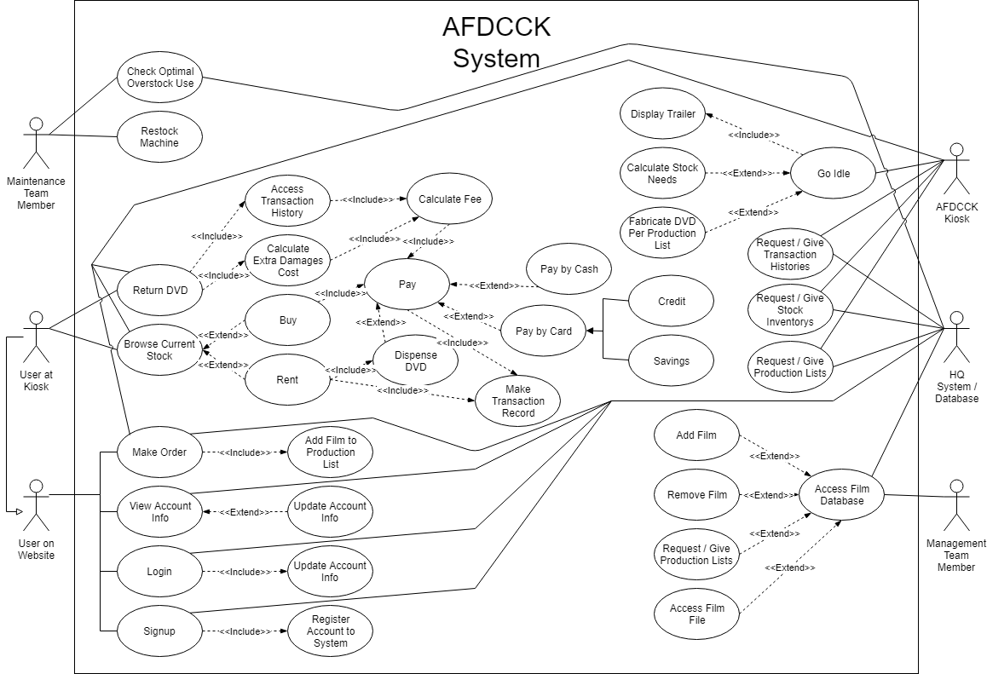

## Example Use Case Scenario:

|  |  |  |
| --- | --- | --- |
| Step # | Actor | Action |
| **1** | User at Kiosk | The user goes to a AFDCCK machine |
| **2** | User at Kiosk | User logs in on the AFDCCK machine |
| **3** | User at Kiosk | User browses Current Stock |
| **4** | User at Kiosk | User Selects DVD to rent |
| **5** | AFDCCK Kiosk | The kiosk makes a transaction record |
| **6** | AFDCCK Kiosk | The kiosk dispenses the DVD |
| **7** | User at Kiosk | The user leaves, and watches the movie |
| **8** | AFDCCK Kiosk | The Kiosk enters idle mode and plays movie trailers on the main screen |
| **9** | HQ System / Database | The HQ System / Database makes various push, and pull requests for the of the transaction to all the kiosk sites |
| **10** | User at Kiosk | The User returns to a AFDCCK machine |
| **11** | User at Kiosk | The User returns the DVD |
| **12** | AFDCCK Kiosk | The Kiosk access the transaction history |
| **13** | AFDCCK Kiosk | The kiosk calculates any extra costs due to damages |
| **14** | AFDCCK Kiosk | The kiosk calculates the total fee |
| **15** | User at Kiosk | The user pays by cash |
| **16** | AFDCCK Kiosk | The kiosk makes a transaction record |

# Functional Requirement Definition (8):

## Functional Requirements:

|  |  |  |  |  |
| --- | --- | --- | --- | --- |
| ID | Case | Pre-Condition | Event | Post-Condition |
| **1** | Browse Current Stock | The has approached the kiosk and signed into their account with their credentials | The user selects to browse current stock | The menu UI changes to one that shows the selection DVDs that are currently in stock |
| **2** | Rent | The user has already signed in to the kiosk and selected the browse current stock option in the main menu | The user chooses to rent a DVD | The kiosk dispenses the requested DVD and makes a record of the transaction |
| **3** | Buy | The user has already signed in to the kiosk and selected the browse current stock option in the main menu | The user chooses to buy a DVD | The kiosk prompts the user to pay, and once they have dispenses a DVD |
| **4** | Pay | The user has either:  . selected to purchase a DVD  Or  . they are returning a DVD they previously rented, and are now required to pay the calculated fee | The user pays the fee | The kiosk records the transaction, (dispenses a DVD if applicable) and the user is logged off and allowed to leave |
| **5** | Dispense DVD | The user has either:  . selected to rent a DVD  Or  . they have just paid for a DVD | The kiosk dispenses a DVD | The user takes the DVD |
| **6** | Make Transaction Record | The user has either:  . selected to rent a DVD  Or  . they have just paid for a DVD | The kiosk makes a transaction | The kiosk stores the transaction |
| **7** | Pay by Cash | The user has been asked to pay a fee | The user chooses to pay the fee with cash | Change is returned and the fee has been paid |
| **8** | Pay by Card | The user has been asked to pay a fee | The user chooses to pay the fee with card | The fee has been paid |

# Requirement Behaviour Tree Diagrams (9):

## Requirement ID 1:

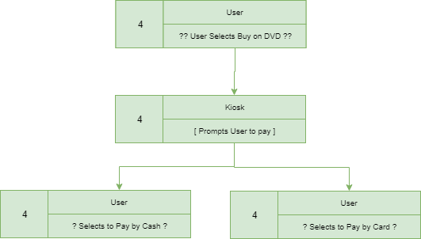

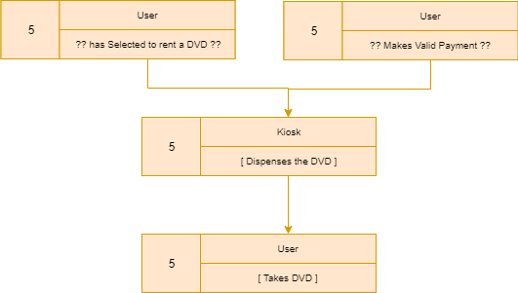

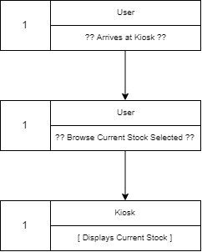

## Requirement ID 2:

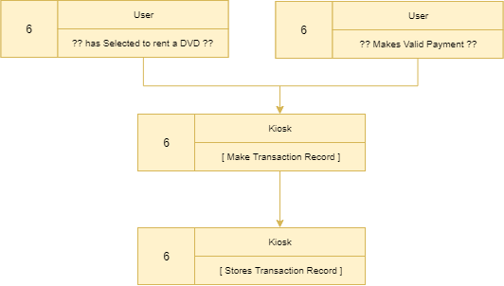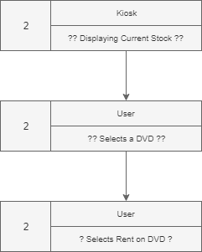

## Requirement ID 3:

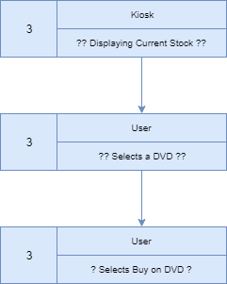

## Requirement ID 4:

## Requirement ID 5:

## Requirement ID 6:

## H:\2813ICT Software Engineering Fundamentals\Diagrams\Requirement Behavior Tree Diagrams\Tree7.pngRequirement ID 7:

## C:\Users\S5132483\AppData\Local\Microsoft\Windows\INetCache\Content.Word\Tree8.pngRequirement ID 8:

# Integrated Behaviour Tree (10):

## IBT Diagram:

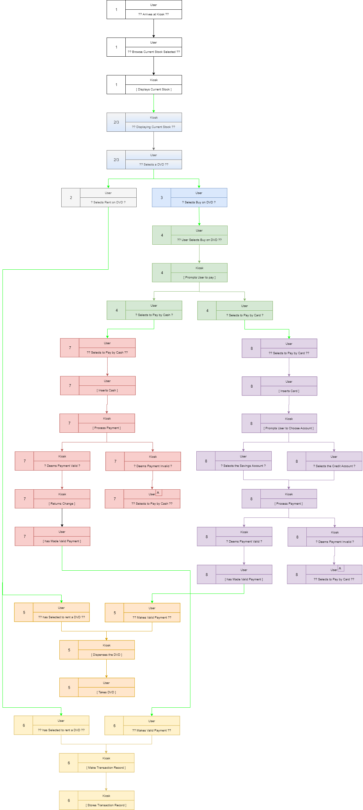

# Component Behaviour Tree (11):

## Full CBT:

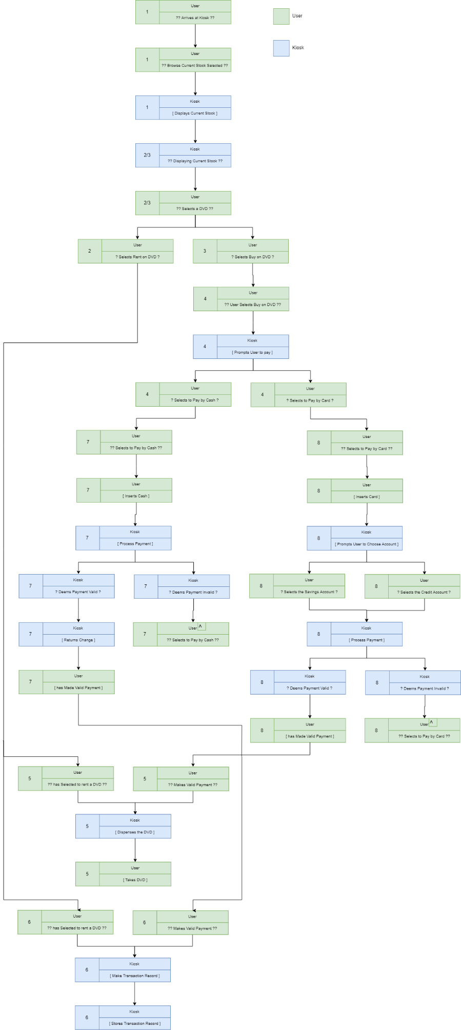

## User CBT:

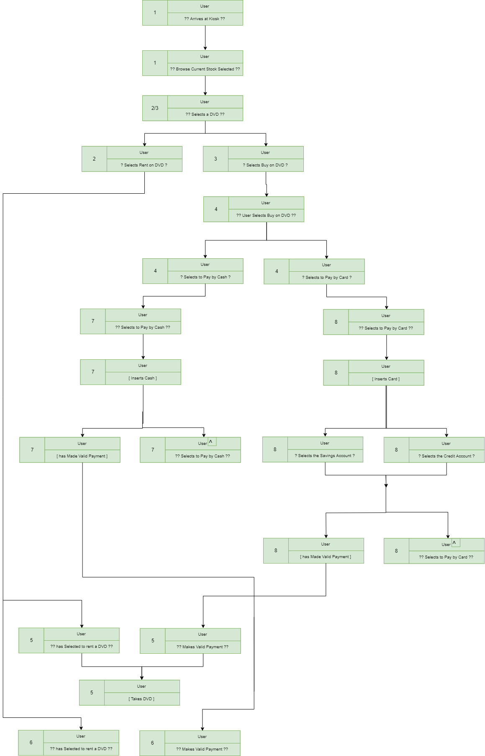

## Kiosk CBT:

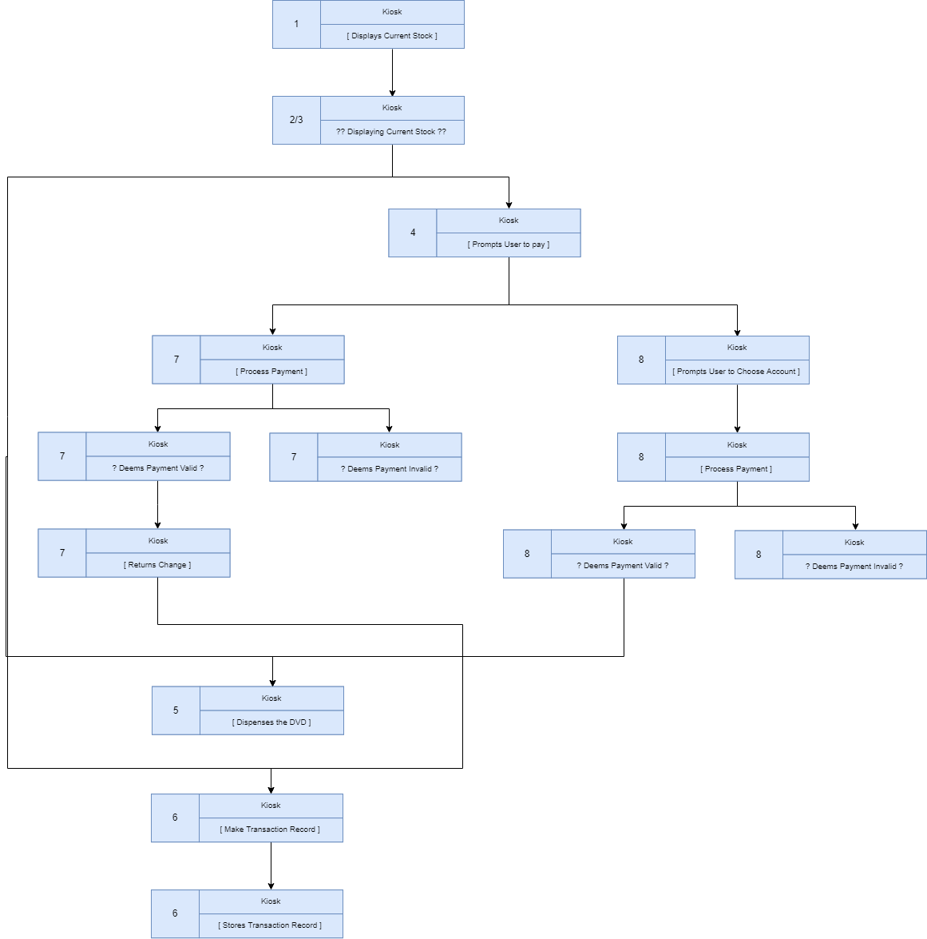

# Component Interaction Network (12):

## CIN Diagram:

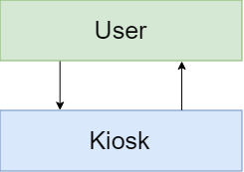

# Domain Class Diagram (13):

## DC Diagram:

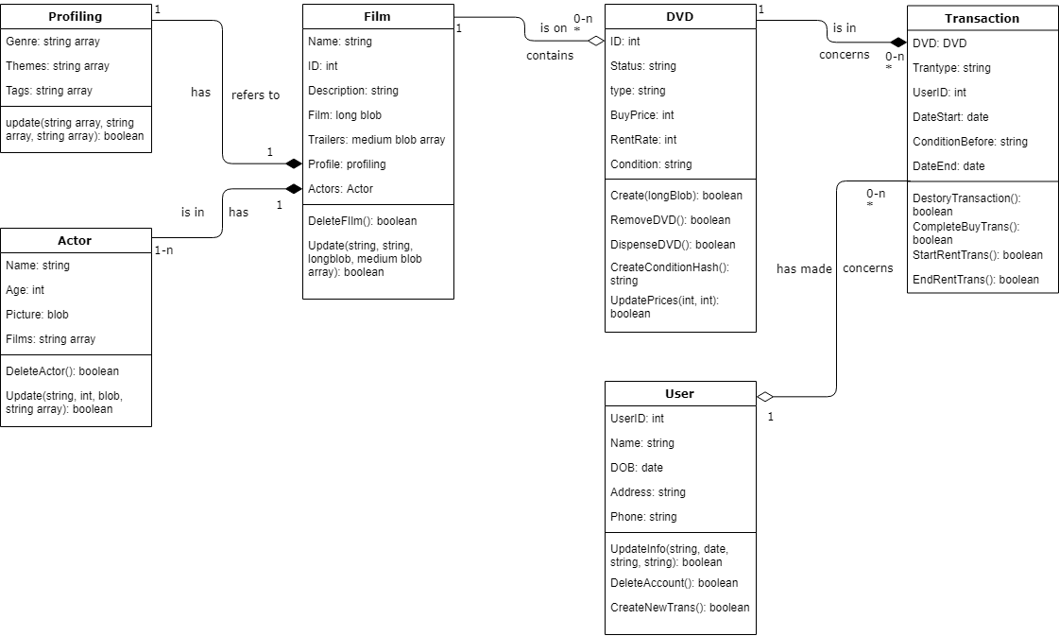

# Appendixes:

## Appendix 1 Bibliography:

Alibaba.com. (2019). Vending Machine Cost,Clothing /food Mart Vending Machine - Buy Vending Machines on Alibaba.com [online]

Available at: <https://www.alibaba.com/product-detail/Vending-machine-cost-clothing-food-mart_60366916331.html?spm=a2700.7724857.normalList.57.55d36dcbwazyL2>

[Accessed 14 Aug. 2019]

Evans, T. (2019). Spacely. Find a space and work your way [online] Spacely. Available at: https://www.spacely.com.au/mcwhirters-retail/pop-up-shop-space576 [Accessed 13 Aug. 2019].

Payscale.com. (2019). Junior Software Engineer Salary in Australia | PayScale [online]

Available at: <https://www.payscale.com/research/AU/Job=Junior_Software_Engineer/Salary>

[Accessed 13 Aug. 2019]

Payscale.com. (2019). Sales Person Salary in Australia | PayScale [online]

Available at: <https://www.payscale.com/research/AU/Job=Sales_Person/Hourly_Rate>

[Accessed 13 Aug. 2019]

Payscale.com. (2019). Senior Software Engineer Salary in Australia | PayScale [online]

Available at: <https://www.payscale.com/research/AU/Job=Senior_Software_Engineer/Salary>

[Accessed 13 Aug. 2019]

Primera Asia Pacific Store. (2019). Primera Bravo 4200 Autoprinter [online]

Available at: <https://store.primera.com.au/primera-bravo-4200-autoprinter/?gclid=Cj0KCQjwv8nqBRDGARIsAHfR9wBkhW1iEMkAD0-1b8ajGsmlq42L52tp5W4_AeeZS9DXCzNniivdG9gaAhWVEALw_wcB>

[Accessed 14 Aug. 2019]

Statista. (2019). Revenue of the U.S. DVD, game and video rental market 2017 | Statista [online]

Available at: <https://www.statista.com/statistics/242671/revenue-of-the-us-recordable-media-manufacturing-industry/>

[Accessed 13 Aug. 2019]

## Appendix 2 Cost Benefits Table with Itemised Costs Table:





## Appendix 3 Revenue market data with Trend graph and equation:



